Boomsma, David, Dr (from Linked In, seedEnergy website)

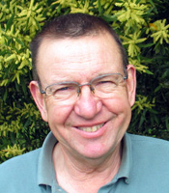

BSc Forestry ANU final year 1966. PhD.

General Manager seedEnergy Pty ltd 2001 – 2013.

David has 38 years of experience in plantation management, silviculture and research. His major research interests lie in forests soils and forest tree nutrition as well as forest tree improvement. Has some first hand experience of pine plantation management in New Zealand, south-eastern United States as well as China and Chile. He worked for ForestrySA for 20 years as a research forester including 10 years as the executive officer for the STBA. He was Chief Executive Officer of the STBA for a further 10 years before establishing seedEnergy.

